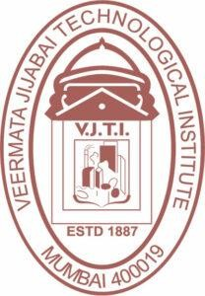

Veermata Jijabai Technological Institute, Mumbai 400019

**Assignment No.:** 02

**Aim :** ToDraw and explain software life cycle with phases**.**

**Objective :**

* To understand the various phases and processes involved in creating software.
* To Learn Various models of software development lifecycle

**Name :** Kiran K Patil **Enrollment No.:** 211070904 **Branch :** Computer Engineering **Batch:** IV

# Software Development Life Cycle (SDLC)

# Overview

A software life cycle model (also termed process model) is a pictorial and diagrammatic representation of the software life cycle. A life cycle model represents all the methods required to make a software product transit through its life cycle stages. It also captures the structure in which these methods are to be undertaken.

In other words, a life cycle model maps the various activities performed on a software product from its inception to retirement. Different life cycle models may plan the necessary development activities to phases in different ways. Thus, no element which life cycle model is followed, the essential activities are contained in all life cycle models though the action may be carried out in distinct orders in different life cycle models. During any life cycle stage, more than one activity may also be carried out.

# SDLC is the acronym of Software Development Life Cycle.

# SDLC is a framework defining tasks performed at each step in the software development process.

# ISO/IEC 12207 is an international standard for software life-cycle processes. It aims to be the standard that defines all the tasks required for developing and maintaining software.

**Need of SDLC**

Without using an exact life cycle model, the development of a software product would not be in a systematic and disciplined manner. When a team is developing a software product, there must be a clear understanding among team representative about when and what to do. Otherwise, it would point to chaos and project failure.

A software life cycle model describes entry and exit criteria for each phase. A phase can begin only if its stage-entry criteria have been fulfilled. So without a software life cycle model, the entry and exit criteria for a stage cannot be recognized. Without software life cycle models, it becomes tough for software project managers to monitor the progress of the project.

## SDLC Cycle

SDLC Cycle represents the process of developing software. SDLC framework includes the following steps:

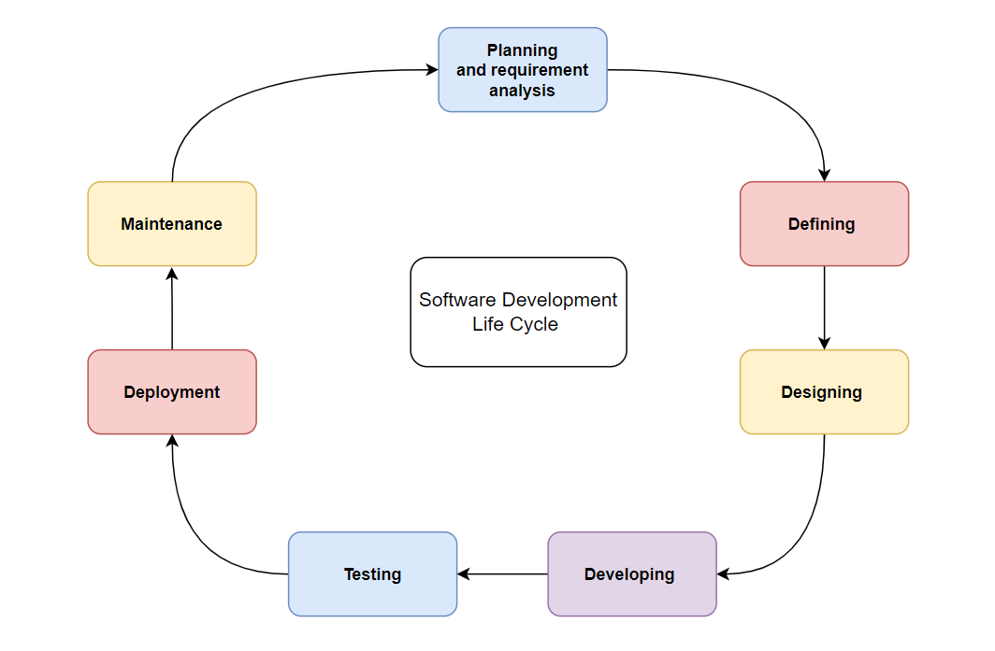

Kiran Patil

211070904

## The stages of SDLC are as follows:

**Stage 1 : Planning and requirement analysis**

* Requirement Analysis is the most important and necessary stage in SDLC.
* The senior members of the team perform it with inputs from all the stakeholders and domain experts or SMEs in the industry.
* Planning for the quality assurance requirements and identifications of the risks associated with the projects is also done at this stage.
* Business analyst and Project organizer set up a meeting with the client to gather all the data like what the customer wants to build, who will be the end user, what is the objective of the product. Before creating a product, a core understanding or knowledge of the product is very necessary.
* **For Example**, A client wants to have an application which concerns money transactions. In this method, the requirement has to be precise like what kind of operations will be done, how it will be done, in which currency it will be done, etc.
* Once the required function is done, an analysis is complete with auditing the feasibility of the growth of a product. In case of any ambiguity, a signal is set up for further discussion.
* Once the requirement is understood, the SRS (Software Requirement Specification) document is created. The developers should thoroughly follow this document and also should be reviewed by the customer for future reference.

**Stage 2: Defining Requirements**

* Once the requirement analysis is done, the next stage is to certainly represent and document the software requirements and get them accepted from the project stakeholders.
* This is accomplished through "SRS"- Software Requirement Specification document which contains all the product requirements to be constructed and developed during the project life cycle.

**Stage 3: Designing the Software**

* The next phase is about to bring down all the knowledge of requirements, analysis, and design of the software project. This phase is the product of the last two, like inputs from the customer and requirement gathering.

**Stage 4 : Developing the project**

* In this phase of SDLC, the actual development begins, and the programming is built. The implementation of design begins concerning writing code. Developers have to follow the coding guidelines described by their management and programming tools like compilers, interpreters, debuggers, etc. are used to develop and implement the code.

**Stage 5 : Testing**

* After the code is generated, it is tested against the requirements to make sure that the products are solving the needs addressed and gathered during the requirements stage.
* During this stage, unit testing, integration testing, system testing, acceptance testing are done.

**Stage 6 : Deployment**

* Once the software is certified, and no bugs or errors are stated, then it is deployed.
* Then based on the assessment, the software may be released as it is or with suggested enhancement in the object segment.
* After the software is deployed, then its maintenance begins.

**Stage 7: Maintenance**

* Once when the client starts using the developed systems, then the real issues come up and requirements to be solved from time to time.
* This procedure where the care is taken for the developed product is known as maintenance.

## SDLC Models

Following are the most important and popular SDLC models followed in the industry

* Waterfall Model
* Incremental Model / Iterative
* Prototyping Models
* Spiral Model
* RAD model

Other related methodologies are Agile Model, RAD Model, Rapid Application Development and Prototyping Models.

# 1. Waterfall Model:

The Waterfall Model was the first Process Model to be introduced. It is also referred to as a linear-sequential life cycle model. It is very simple to understand and use. In a waterfall model, each phase must be completed before the next phase can begin and there is no overlapping in the phases.

The Waterfall model is the earliest SDLC approach that was used for software development. The waterfall Model illustrates the software development process in a linear sequential flow. This means that any phase in the development process begins only if the previous phase is complete. In this waterfall model, the phases do not overlap.

The following illustration is a representation of the different phases of the Waterfall Model.

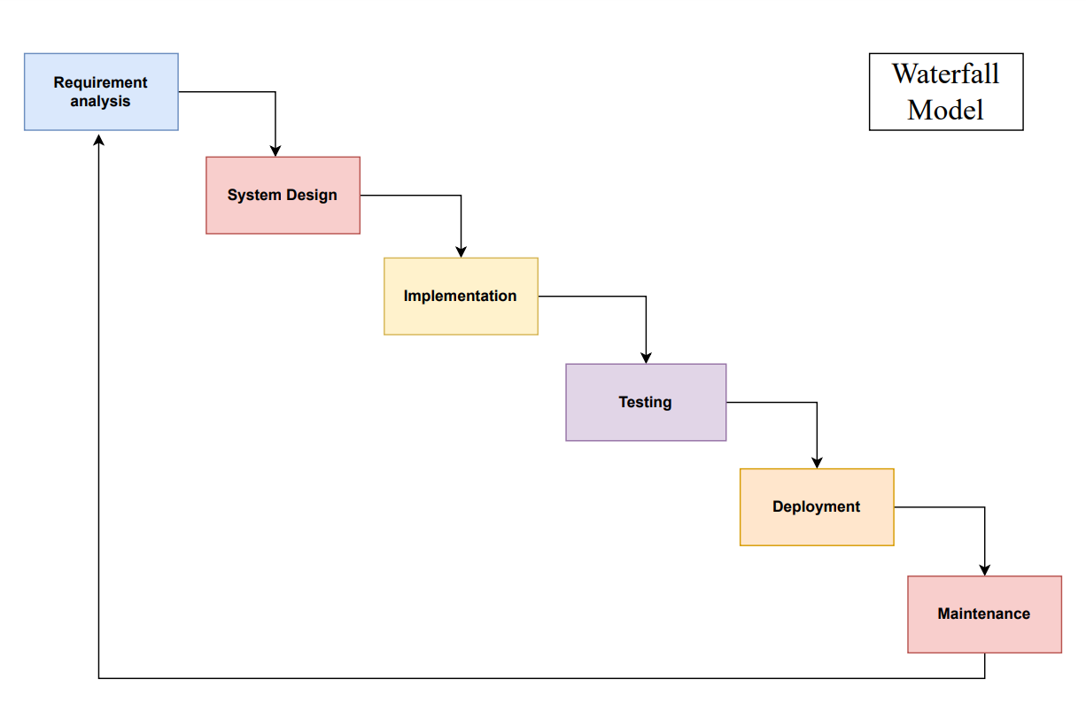

Kiran Patil

211070904

**The sequential phases in Waterfall model are :**

* **Requirement Gathering and analysis** − All possible requirements of the system to be developed are captured in this phase and documented in a requirement specification document.
* **System Design** − The requirement specifications from first phase are studied in this phase and the system design is prepared. This system design helps in specifying hardware and system requirements and helps in defining the overall system architecture.
* **Implementation** − With inputs from the system design, the system is first developed in small programs called units, which are integrated in the next phase. Each unit is developed and tested for its functionality, which is referred to as Unit Testing.
* **Integration and Testing** − All the units developed in the implementation phase are integrated into a system after testing of each unit. Post integration the entire system is tested for any faults and failures.
* **Deployment of system** − Once the functional and non-functional testing is done; the product is deployed in the customer environment or released into the market.
* **Maintenance** − There are some issues which come up in the client environment. To fix those issues, patches are released. Also to enhance the product some better versions are released. Maintenance is done to deliver these changes in the customer environment

All these phases are cascaded to each other in which progress is seen as flowing steadily downwards (like a waterfall) through the phases. The next phase is started only after the defined set of goals are achieved for previous phase and it is signed off, so the name "Waterfall Model". In this model, phases do not overlap.

## Waterfall Model: Application

* Requirements are very well documented, clear and fixed.
* Product definition is stable.
* Technology is understood and is not dynamic.
* There are no ambiguous requirements.
* Ample resources with required expertise are available to support the product.
* The project is short.

## Waterfall Model - Advantages

* Simple and easy to understand and use
* Easy to manage due to the rigidity of the model. Each phase has specific deliverables and a review process.
* Phases are processed and completed one at a time.
* Works well for smaller projects where requirements are very well understood.
* Clearly defined stages.
* Well understood milestones.
* Easy to arrange tasks.
* Process and results are well documented.

**Waterfall Model - Disadvantages**

* No working software is produced until late during the life cycle.
* High amounts of risk and uncertainty.
* Not a good model for complex and object-oriented projects.
* Poor model for long and ongoing projects.
* Not suitable for the projects where requirements are at a moderate to high risk of changing.
* It is difficult to measure progress within stages.
* Cannot accommodate changing requirements.

**2. Incremental Model / Iterative Model :**

Incremental Model is a process of software development where requirements divided into multiple standalone modules of the software development cycle. In this model, each module goes through the requirements, design, implementation and testing phases. Every subsequent release of the module adds function to the previous release. The process continues until the complete system achieved.

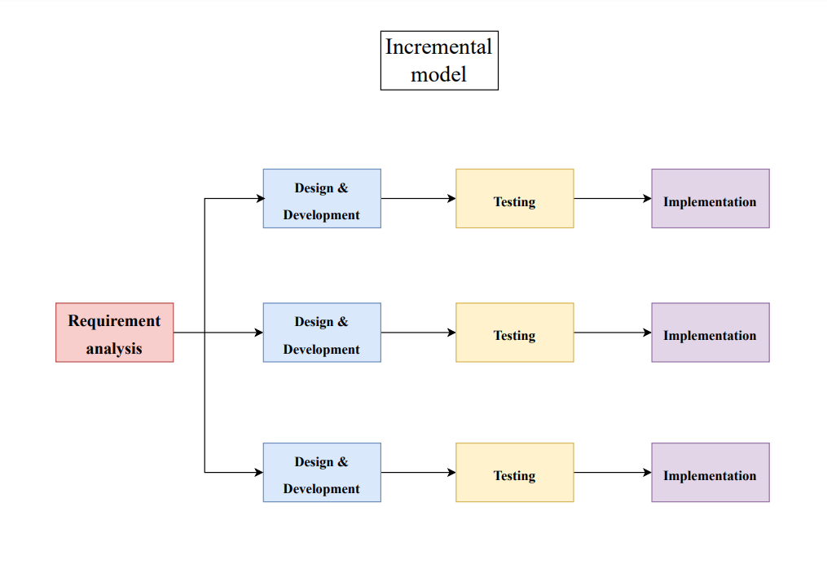

Kiran Patil

211070904

## The various phases of incremental model are as follows:

**1. Requirement analysis :** In the first phase of the incremental model, the product analysis expertise identifies the requirements. And the system functional requirements are understood by the requirement analysis team. To develop the software under the incremental model, this phase performs a crucial role.

**2. Design & Development :** In this phase of the Incremental model of SDLC, the design of the system functionality and the development method are finished with success. When software develops new practicality, the incremental model uses style and development phase.

**3. Testing :** In the incremental model, the testing phase checks the performance of each existing function as well as additional functionality. In the testing phase, the various methods are used to test the behavior of each task.

**4. Implementation :** Implementation phase enables the coding phase of the development system. It involves the final coding that design in the designing and development phase and tests the functionality in the testing phase. After completion of this phase, the number of the product working is enhanced and upgraded up to the final system product

## When we use the Incremental Model?

* When the requirements are superior.
* A project has a lengthy development schedule.
* When Software team are not very well skilled or trained.
* When the customer demands a quick release of the product.
* You can develop prioritized requirements first.

## Advantage of Incremental Model

* Errors are easy to be recognized.
* Easier to test and debug
* More flexible.
* Simple to manage risk because it handled during its iteration.
* The Client gets important functionality early.

## Disadvantage of Incremental Model

* Need for good planning
* Total Cost is high.
* Well defined module interfaces are needed.

# 3. Prototype Model

The prototype model requires that before carrying out the development of actual software, a working prototype of the system should be built. A prototype is a toy implementation of the system. A prototype usually turns out to be a very crude version of the actual system, possible exhibiting limited functional capabilities, low reliability, and inefficient performance as compared to actual software. In many instances, the client only has a general view of what is expected from the software product. In such a scenario where there is an absence of detailed information regarding the input to the system, the processing needs, and the output requirement, the prototyping model may be employed.

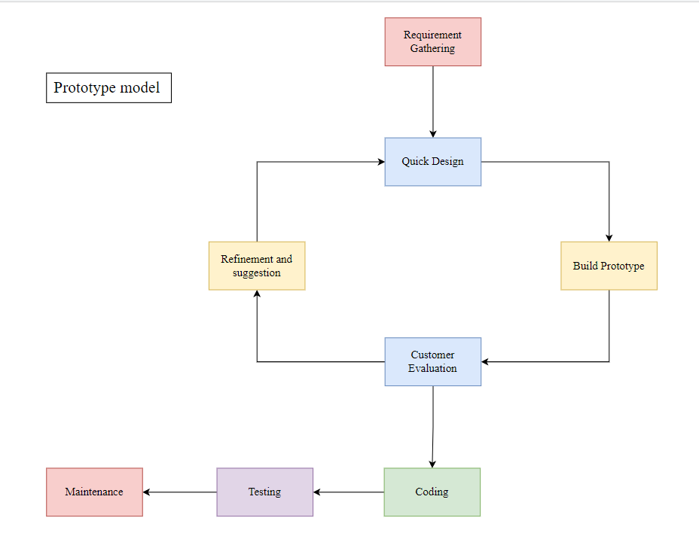

Kiran Patil

211070904

**Prototyping Model has following six SDLC phases as follow:**

### Requirements gathering and analysis

A prototyping model starts with requirement analysis. In this phase, the requirements of the system are defined in detail. During the process, the users of the system are interviewed to know what is their expectation from the system.

### Quick design

The second phase is a preliminary design or a quick design. In this stage, a simple design of the system is created. However, it is not a complete design. It gives a brief idea of the system to the user. The quick design helps in developing the prototype.

### Build a Prototype

In this phase, an actual prototype is designed based on the information gathered from quick design. It is a small working model of the required system.

### Initial user evaluation

In this stage, the proposed system is presented to the client for an initial evaluation. It helps to find out the strength and weakness of the working model. Comment and suggestion are collected from the customer and provided to the developer.

### Refining prototype

If the user is not happy with the current prototype, you need to refine the prototype according to the user’s feedback and suggestions.

This phase will not over until all the requirements specified by the user are met. Once the user is satisfied with the developed prototype, a final system is developed based on the approved final prototype.

### Implement Product and Maintain

Once the final system is developed based on the final prototype, it is thoroughly tested and deployed to production. The system undergoes routine maintenance for minimizing downtime and prevent large-scale failures.

**Types Of prototypes model**

### Throwaway/Rapid Prototyping

Throwaway prototyping is also called as rapid or close ended prototyping. This type of prototyping uses very little efforts with minimum requirement analysis to build a prototype. Once the actual requirements are understood, the prototype is discarded and the actual system is developed with a much clear understanding of user requirements.

### Evolutionary Prototyping

Evolutionary prototyping also called as breadboard prototyping is based on building actual functional prototypes with minimal functionality in the beginning. The prototype developed forms the heart of the future prototypes on top of which the entire system is built. By using evolutionary prototyping, the well-understood requirements are included in the prototype and the requirements are added as and when they are understood.

### Incremental Prototyping

Incremental prototyping refers to building multiple functional prototypes of the various sub-systems and then integrating all the available prototypes to form a complete system.

### Extreme Prototyping

Extreme prototyping is used in the web development domain. It consists of three sequential phases. First, a basic prototype with all the existing pages is presented in the HTML format. Then the data processing is simulated using a prototype services layer. Finally, the services are implemented and integrated to the final prototype. This process is called Extreme Prototyping used to draw attention to the second phase of the process, where a fully functional UI is developed with very little regard to the actual services.

**Use of the prototype model :**

The Prototyping Model should be used when the requirements of the product are not clearly understood or are unstable. It can also be used if requirements are changing quickly. This model can be successfully used for developing user interfaces, high technology software-intensive systems, and systems with complex algorithms and interfaces. It is also a very good choice to demonstrate the technical feasibility of the product.

**Advantage of Prototype Model**

1. Reduce the risk of incorrect user requirement
2. Good where requirement are changing/uncommitted
3. Regular visible process aids management
4. Support early product marketing
5. Reduce Maintenance cost.
6. Errors can be detected much earlier as the system is made side by side.

## Disadvantage of Prototype Model

1. An unstable/badly implemented prototype often becomes the final product.
2. Require extensive customer collaboration
   * Costs customer money
   * Needs committed customer
   * Difficult to finish if customer withdraw
   * May be too customer specific, no broad market
3. Difficult to know how long the project will last.
4. Easy to fall back into the code and fix without proper requirement analysis, design, customer evaluation, and feedback.
5. Prototyping tools are expensive.
6. Special tools & techniques are required to build a prototype.
7. It is a time-consuming process.

# 4. Spiral Model

The spiral model, initially proposed by Boehm, is an evolutionary software process model that couples the iterative feature of prototyping with the controlled and systematic aspects of the linear sequential model. It implements the potential for rapid development of new versions of the software. Using the spiral model, the software is developed in a series of incremental releases. During the early iterations, the additional release may be a paper model or prototype. During later iterations, more and more complete versions of the engineered system are produced.

**The Spiral Model is shown in fig:**

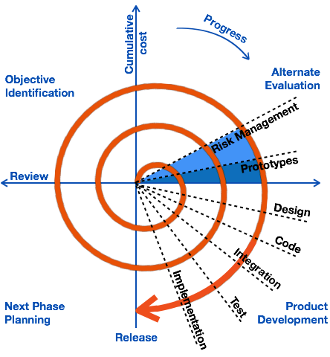

Kiran Patil

211070904

**Each cycle in the spiral is divided into four parts:**

1. **Objective setting:** Each cycle in the spiral starts with the identification of purpose for that cycle, the various alternatives that are possible for achieving the targets, and the constraints that exists.
2. **Risk Assessment and reduction:** The next phase in the cycle is to calculate these various alternatives based on the goals and constraints. The focus of evaluation in this stage is located on the risk perception for the project.
3. **Development and validation:** The next phase is to develop strategies that resolve uncertainties and risks. This process may include activities such as benchmarking, simulation, and prototyping.
4. **Planning:** Finally, the next step is planned. The project is reviewed, and a choice made whether to continue with a further period of the spiral. If it is determined to keep, plans are drawn up for the next step of the project.

The development phase depends on the remaining risks. For example, if performance or user-interface risks are treated more essential than the program development risks, the next phase may be an evolutionary development that includes developing a more detailed prototype for solving the risks.

The **risk-driven** feature of the spiral model allows it to accommodate any mixture of a specification-oriented, prototype-oriented, simulation-oriented, or another type of approach.

An essential element of the model is that each period of the spiral is completed by a review that includes all the products developed during that cycle, including plans for the next cycle. The spiral model works for development as well as enhancement projects.

## When to use Spiral Model?

* When deliverance is required to be frequent.
* When the project is large
* When requirements are unclear and complex
* When changes may require at any time
* Large and high budget projects

## Advantages

* High amount of risk analysis
* Useful for large and mission-critical projects.

## Disadvantages

* Can be a costly model to use.
* Risk analysis needed highly particular expertise
* Doesn't work well for smaller projects.

# 5. RAD (Rapid Application Development) Model

RAD is a linear sequential software development process model that emphasizes a concise development cycle using an element based construction approach. If the requirements are well understood and described, and the project scope is a constraint, the RAD process enables a development team to create a fully functional system within a concise time period.

RAD (Rapid Application Development) is a concept that products can be developed faster and of higher quality through:

* Gathering requirements using workshops or focus groups
* Prototyping and early, reiterative user testing of designs
* The re-use of software components
* A rigidly paced schedule that refers design improvements to the next product version
* Less formality in reviews and other team communication

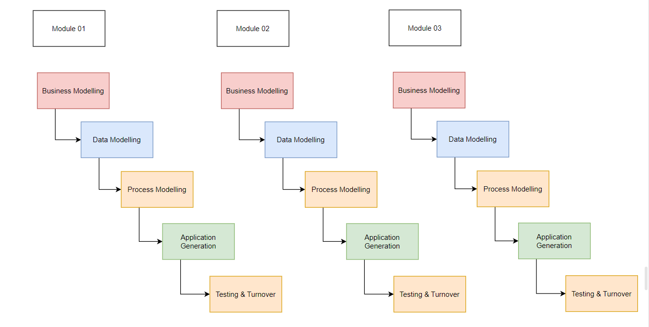

Kiran Patil

211070904

## The various phases of RAD are as follows:

**1. Business Modelling :** The information flow among business functions is defined by answering questions like what data drives the business process, what data is generated, who generates it, where does the information go, who process it and so on.

**2. Data Modelling :** The data collected from business modeling is refined into a set of data objects (entities) that are needed to support the business. The attributes (character of each entity) are identified, and the relation between these data objects (entities) is defined.

**3. Process Modelling:** The information object defined in the data modeling phase are transformed to achieve the data flow necessary to implement a business function. Processing descriptions are created for adding, modifying, deleting, or retrieving a data object.

**4. Application Generation:** Automated tools are used to facilitate construction of the software; even they use the 4th GL techniques.

**5. Testing & Turnover:** Many of the programming components have already been tested since RAD emphasis reuse. This reduces the overall testing time. But the new part must be tested, and all interfaces must be fully exercised.

## When to use RAD Model?

* When the system should need to create the project that modularizes in a short span time (2-3 months).
* When the requirements are well-known.
* When the technical risk is limited.
* When there's a necessity to make a system, which modularized in 2-3 months of period.
* It should be used only if the budget allows the use of automatic code generating tools.

## Advantages of RAD Model

* This model is flexible for change.
* In this model, changes are adoptable.
* Each phase in RAD brings highest priority functionality to the customer.
* It reduced development time.
* It increases the reusability of features.

## Disadvantage of RAD Model

* It required highly skilled designers.
* All application is not compatible with RAD.
* For smaller projects, we cannot use the RAD model.
* On the high technical risk, it's not suitable.
* Required user involvement.

**Conclusion :**

In conclusion we can say that the software development lifecycle (SDLC) is a process for creating high-quality software products efficiently and effectively, by following a structured approach through all stages of development.